**#Generator Function : creates its objects on the fly.**

def f1():

for i in range(5):

yield(i*i)

for j in **f1():**

print (j)

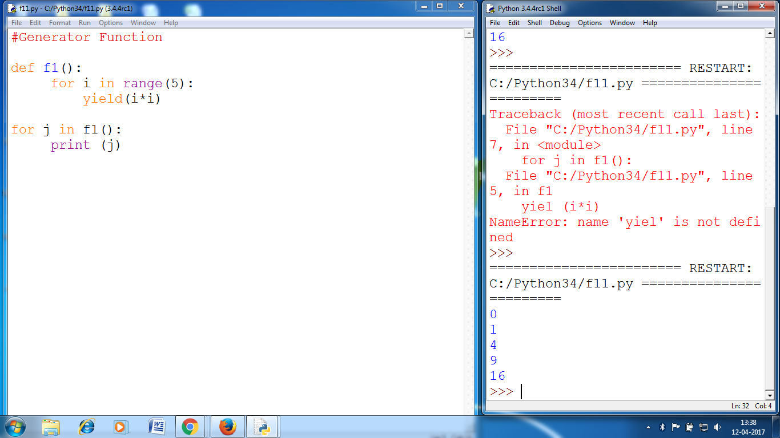

ls=[]

def f1():

for i in range(5):

yield(i*i)

ls.append(i*i)

for j in f1():

print (j)

for j in ls:

print(j)

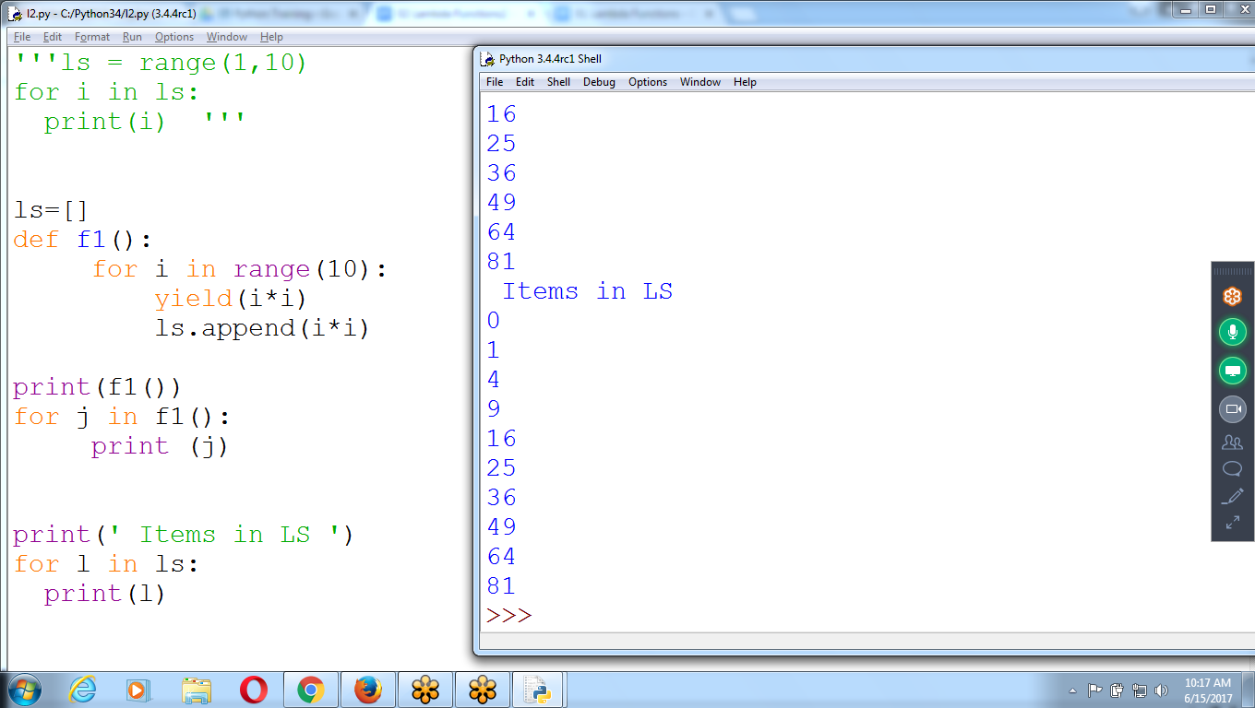

'''ls = range(1,10)

for i in ls:

print(i) '''

ls=[]

def f1():

for i in range(10):

yield(i*i)

ls.append(i*i)

print(f1())

for j in f1():

print (j)

print(' Items in LS ')

for l in ls:

print(l)